9.79: a) See Exercise 9.50.

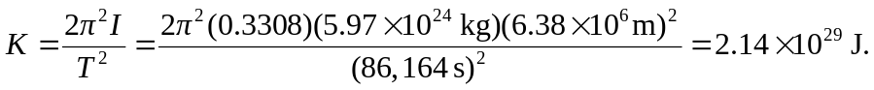
b)

c) Since the Earth’s moment on inertia is less than that of a uniform sphere, more of the Earth’s mass must be concentrated near its center.

